
28th JANUARY 2026

Lagos State Government

BUDGET IMPLEMENTATION REPORT QUARTER 4 2025

Contents
1 Summary of Performance 3
1.A Introduction 3
1.B Revenue Performance 3
1.C Recurrent Expenditure Performance 3
1.D Capital Expenditure Performance 4
1.E Conclusions 4
1.F Summary Budget Implementation Graphs 5
1.G Summary Budget Implementation Report 7
2 Budget Implementation Reports by NCOA Segments 8
2.A Revenue by Administrative Classification 8
2.B Expenditure by Administrative Classification 16
2.C Expenditure by Economic Classification 35
2.D Expenditure by Functional Classification 40
2.E Expenditure by Programme Classification 50
3 Capital Expenditure Details 56
4 Primary Healthcare Budget Performance 65
4.A Overview 65
4.B Budget Implementation Reports by NCOA Segment 66
5 Basic Education Budget Performance 70
5.A Overview 70
5.B Budget Implementation Reports by NCOA Segment 71

List of Graphical Presentations
Figure 1: Fiscal Performance Overview for Quarter 5
Figure 2: Fiscal Performance Overview for Year to Date 6
Figure 3: Summary of Primary Health Care Budget Performance for Quarter and Year to Date 65
Figure 4: Summary of Basic Education Budget Performance Year to Date 70

List of Reports
Table 1: Budget Implementation Summary 7
Table 2: Total Revenue by Administrative Classification 8
Table 3: Total Revenue by Economic Classification 13
Table 4: Total Expenditure by Administrative Classification 16
Table 5: Personnel Expenditure by Administrative Classification 21
Table 6: Overhead Expenditure by Administrative Classification 24
Table 7: Capital Expenditure by Administrative Classification 29
Table 8: Other Expenditure by Administrative Classification 34
Table 9: Total Expenditure by Economic Classification 35
Table 10: Total Expenditure by Functional Classification 40
Table 11: Personnel Expenditure by Functional Classification 43
Table 12: Overhead Expenditure by Functional Classification 45
Table 13: Capital Expenditure by Functional Classification 47
Table 14: Other Expenditure by Functional Classification 49
Table 15: Total Expenditure by Programme Classification 50
Table 16: Personnel Expenditure by Programme Classification 52
Table 17: Overhead Expenditure by Programme Classification 53
Table 18: Capital Expenditure by Programme Classification 54
Table 19: Other Expenditure by Programme Classification 55
Table 20: Capital Expenditure by Project 56
Table 21: Primary Healthcare Expenditure by Administrative Classification 66
Table 22: Primary Healthcare Expenditure by Functional Classification 66
Table 23: Primary Healthcare Expenditure by Programme Classification 67
Table 24: Primary Healthcare Expenditure by Economic Classification 68
Table 25: Basic Education Expenditure by Administrative Classification 71
Table 26: Basic Education Expenditure by Functional Classification 71
Table 27: Basic Education Expenditure by Programme Classification 71
Table 28: Basic Education Expenditure by Economic Classification 72

- Summary of Performance
  - Introduction
This Budget Implementation Report for Lagos State is prepared quarterly and issued within 30 days from the end of each quarter.
This report includes the original approved budget appropriations for Y2025 against each organisational unit for each of the core economic classification of expenditures (Personnel, Overheads, Capital, and Others); the actual expenditures for the quarter Q4, attributed to each organisational unit, as well as the cumulative expenditures for year to date, and balances against each of the revenue and expenditure appropriations.
This Q4 report is assessed against the Y2025 Final Budget. The Final Budget comprises the Original Budget and the budget revisions implemented during the year, which were carried out in the third quarter. These revisions were undertaken to ensure optimal budget performance. The core economic classifications, as per the National Chart of Accounts (NCOA) refer to:
- Revenue – Economic Account Type 1
- Personnel Expenditure – Economic Sub-Account Type 21
- Overheads Expenditure - Economic Account Class 2202
- Capital Expenditure - Economic Sub-Account Type 23
- Other Expenditures (covering Loans, Grants and Contributions, Subsidies, Debt Service and Transfer Payments) - Economic Account Classes 2203-2209 as applicable
This report includes 4 and 5 detailed reports on Primary Healthcare and Basic Education expenditures, respectively.
This Budget Performance Report is produced by the Ministry of Planning and Budget in collaboration with the State Treasury Office and published on the Lagos State website.
  - Revenue Performance
The 4th Quarter Total Revenue of ₦2.627tn (Recurrent Revenue, Opening balance and Capital Receipt including Financing) Performance for the Period ended 31st December 2025 performed at 90.1%, while Capital Receipt and Financing performance was 89.3%. The Cumulative budget performance for Aids/Grants was 30.8% (₦16.9bn). The low Aids/Grants performance reported on the Revenue line is primarily due to the dwindling availability of grants and shifts in priorities of donors globally. The policies of global powers with regards to the development sector and grants has led to a poor performance of the State’s Aids/Grants receipt.
  - Recurrent Expenditure Performance
The 4th Quarter Recurrent Expenditure (Debt & Non-Debt) Performance for the Y2025 stood at ₦1.064trn representing 82.3%.
- Personnel Costs performed at 88% YTD, reflective of prioritized spending on human resources viz a viz wage award.
- Overhead Costs recorded 76% performance YTD; this is driven by controls on operational expenses. These achievements demonstrate the impact of tightened public financial management controls, reduced fiscal leakages, and optimized procurement processes
The above performances of the recurrent expenditures across headlines reflects the State’s Public Financial Management Reforms and are attributable to the tight expenditure controls that are put in place to reduce leakages and optimise procurements of consumables through the deepening of the State’s procurement process. This is further supported by the provision of necessary dependencies to MDAs responsible for expenditure management and control, thereby enabling them to effectively deliver on their core mandates while preserving fiscal space for capital projects.
  - Capital Expenditure Performance
The 4th Quarter Total Capital Expenditure Performance for the Period ended 31st December, 2025 was ₦1.773trn, achieving 85.6% of the Final budget amount of ₦2.072trn for Y2025. This performance underscores the State Government's steadfast commitment to enhancing infrastructure and fostering a conducive environment for economic growth. It is pertinent to note that, the State's stringent expenditure management and rigorous payment controls played a pivotal role in ensuring that resources were judiciously utilized. These measures not only contributed to the impressive performance but also attest to the government's accountability in ensuring infrastructural sustainability as well as optimal value for money from its capital expenditure.
To support the performance, the Administration is poised to sustain its Revenue Generation drive, attract more private participation and collaboration in pursuant to closing its infrastructure deficit.

  - Conclusions
The Y2025 Budget of Sustainability of N3,366,815,224,143.85, is strategically crafted to promote continuity, resilience, and sustained growth for all Lagosian. This Budget prioritises sustainable infrastructure and environmental stewardship, drives economic diversification, advances social inclusion and human capital development, and strengthens governance and institutional reforms. It reflects our unwavering commitment to building a future-ready Lagos resilient, inclusive, and thriving for generations to come.
The following pointers are highlighted below:
• Total Capital Estimate for the Year is N2.072trn, while Recurrent Projection is N1.293trn representing 62:38 Capital/Recurrent Ratio.
• The Q4 2025 Total Recurrent Revenue recorded a year-to-date performance of 90%
• Q4 Recurrent Expenditure recorded a performance of 82.3% year to date, for the period ended 31st December 2025. supported by effective financial management reforms.
• Q4 CAPEX closed at 85.6% for the period ended 31st December 2025, emphasizing the government’s goal of closing infrastructure deficit across the State
• Overall Budget performance for YTD stood at 84.3%, underscoring sustained efforts to meet fiscal and developmental goals.

Summary Budget Implementation Graphs
Figure 1: Fiscal Performance Overview for Quarter

Figure 2: Fiscal Performance Overview for Year to Date

Summary Budget Implementation Report
Table 1: Budget Implementation Summary

Budget Implementation Reports by NCOA Segments

Revenue by Administrative Classification
Table 2: Total Revenue by Administrative Classification

Revenue by Economic Classification
Table 3: Total Revenue by Economic Classification

Expenditure by Administrative Classification
Table 4: Total Expenditure by Administrative Classification

Table 5: Personnel Expenditure by Administrative Classification

Table 6: Overhead Expenditure by Administrative Classification

Table 7: Capital Expenditure by Administrative Classification

Table 8: Other Expenditure by Administrative Classification

Expenditure by Economic Classification
Table 9: Total Expenditure by Economic Classification

Expenditure by Functional Classification
Table 10: Total Expenditure by Functional Classification

Table 11: Personnel Expenditure by Functional Classification

Table 12: Overhead Expenditure by Functional Classification

Table 13: Capital Expenditure by Functional Classification

Table 14: Other Expenditure by Functional Classification

Expenditure by Programme Classification
Table 15: Total Expenditure by Programme Classification

Table 16: Personnel Expenditure by Programme Classification
Table 17: Overhead Expenditure by Programme Classification

Table 18: Capital Expenditure by Programme Classification
Table 19: Other Expenditure by Programme Classification

Capital Expenditure Details
Capital Expenditure Projects related to Primary Healthcare have a blue marker whilst those related to Basic Education have a green marker.
Table 20: Capital Expenditure by Project

Primary Healthcare Budget Performance

Overview
The total recurrent budget for Primary Healthcare for Y2025 is ₦17,362,639,636.52 out of which ₦17,257,449,837.46 representing 99.4% was recorded as performance for the 4th quarter (Jan – Dec). The primary healthcare expenditure was measured through the health sector objectives (Programme segment level 2). The personnel performance is 100% while the overhead is 94.8%. The capital budget for primary healthcare is ₦16,324,520,323.57 out of which ₦16,232,025,898.13 representing 99.4% was achieved as performance for the 4th quarter (Jan – Dec).
A summary of the performance Year to Date (YTD) against the original budget is provided below for the main economic classifications of expenditure, and YTD against the programme segment (Objective level).
Figure 3: Summary of Primary Health Care Budget Performance for Quarter and Year to Date
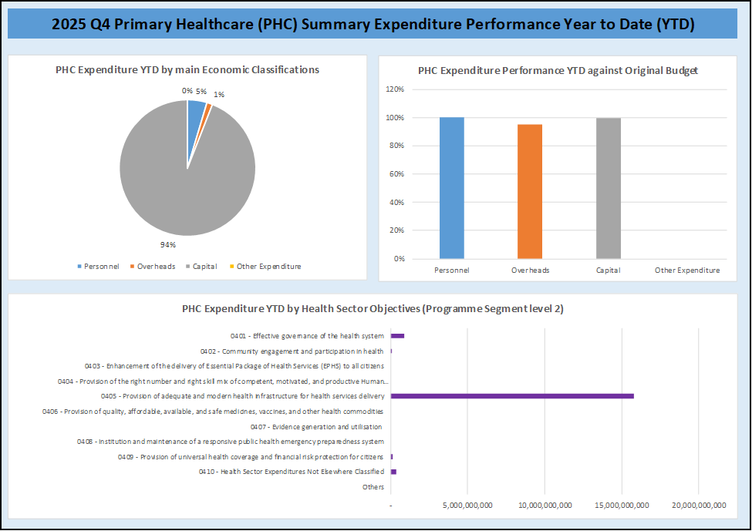

Budget Implementation Reports by NCOA Segment
Table 21: Primary Healthcare Expenditure by Administrative Classification
Table 22: Primary Healthcare Expenditure by Functional Classification
Table 23: Primary Healthcare Expenditure by Programme Classification

Table 24: Primary Healthcare Expenditure by Economic Classification

Basic Education Budget Performance

Overview
The total recurrent Final budget for Basic Education for the year 2025 is ₦19,745,889,561.23 out of which ₦14,005,622,226.08 representing 70.9% was recorded as performance for the 4th quarter (Jan – Dec). The Basic Education expenditure was measured through the Education sector objectives (Programme segment level 2). The personnel performance is ₦653,917,212 (10.5%) while the overhead is ₦5,393,304,656 (100%). The capital budget for Basic Education is ₦7,958,400,358.08 (97.9%) performance achieved against ₦8,126,675,686.24 Final budget.
A summary of the performance Year to Date (YTD) against the original budget is provided below for the main economic classifications of expenditure, and YTD against the programme segment (Objective level).
Figure 4: Summary of Basic Education Budget Performance Year to Date
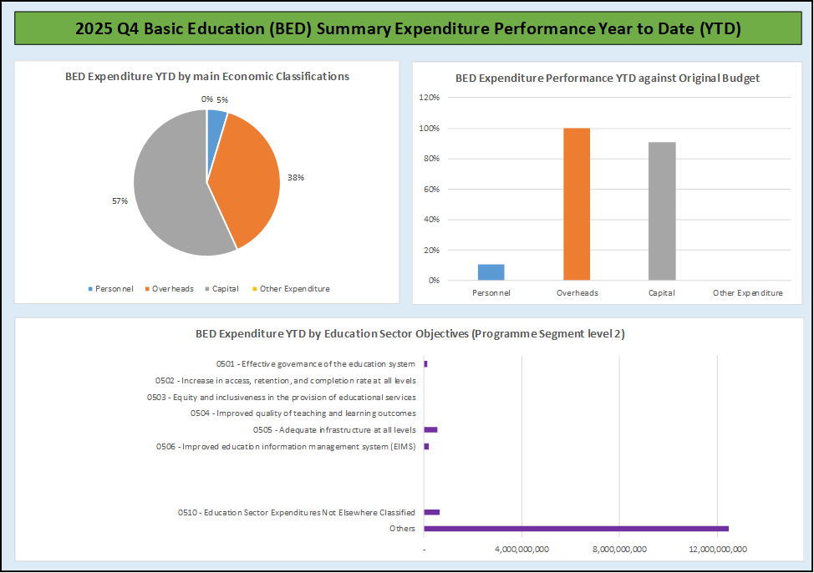

Budget Implementation Reports by NCOA Segment
Table 25: Basic Education Expenditure by Administrative Classification
Table 26: Basic Education Expenditure by Functional Classification
Table 27: Basic Education Expenditure by Programme Classification

Table 28: Basic Education Expenditure by Economic Classification

